**Creating a website for your Android project**

* Open the Github client for Windows – login if necessary
* Select (or clone) your website repository – *username.github.io* where username is your github login.
* Rename the *index.html* in your directory to *python.html*.
* Open notepad++ and create a blank file. Save it in the repository directory you created earlier, with the name *android.html*. Be sure to select “All files” from the drop down select box on the Save as screen.

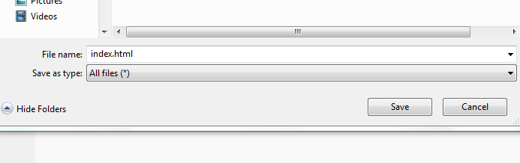

* In this file, create a test HTML document and save it. Use your cheat sheet to put in some example information!
* Save your work, and commit any changes to Github. If your page doesn’t show up on your website, make sure you have a verified email address.
* While Github loads our site, we can now build a website to display our project. The website should contain:
  + Your description of the project
  + Your reflections on the project
  + A link to the apk file
  + A picture or video of the app running
  + At least one snippet of code with your explanation of what the code is accomplishing. Pick something that you had to struggle to get working!
* Finally, create a new *index.html* that links to both your android project and your python project!

-10pts for anything missing from the above list.

Use the cheat sheet to put your website together. It can be simple at first – we will learn more about styling in later lessons.

**HTML Cheat sheet**

Every page:

<html>  
<head>  
 <title>Your page title</title>  
</head>  
<body>

Insert your page content here

</body>  
</html>

|  |  |
| --- | --- |
| **Tag** | **Use** |
| <p></p> | Regular text |
| <h1></h1> | Header text |
| <h2></h2> | Smaller header text |
| <img src=”filename.jpg” /> | Embed an image |
| <ul><li>List item</li></ul> | Create a bullet point list |
| <a href=”google.com”>Google</a> | Create a link |